first theory

Arquillian makes integration testing a breeze!
Arquillian brings the test to the runtime so you don’t have to manage the runtime from the test (or the build). Arquillian eliminates this burden by covering all aspects of test execution, which entails:
- Managing the lifecycle of the container (or containers)
- Bundling the test case, dependent classes and resources into a ShrinkWrap archive (or archives)
- Deploying the archive (or archives) to the container (or containers)
- Enriching the test case by providing dependency injection and other declarative services
- Executing the tests inside (or against) the container
- Capturing the results and returning them to the test runner for reporting
To avoid introducing unnecessary complexity into the developer’s build environment, Arquillian integrates seamlessly with familiar testing frameworks (e.g., JUnit 4, TestNG 5), allowing tests to be launched using existing IDE, Ant and Maven test plugins — without any add-ons.
http://arquillian.org/

some practice
git clone https://github.com/RadekHulboj/MBO_Axxiome.git
The project is built with maven build tool: run command mvn clean package
The tests are self-explanatory.
How to run unit test from Intellij idea
Add the junit test
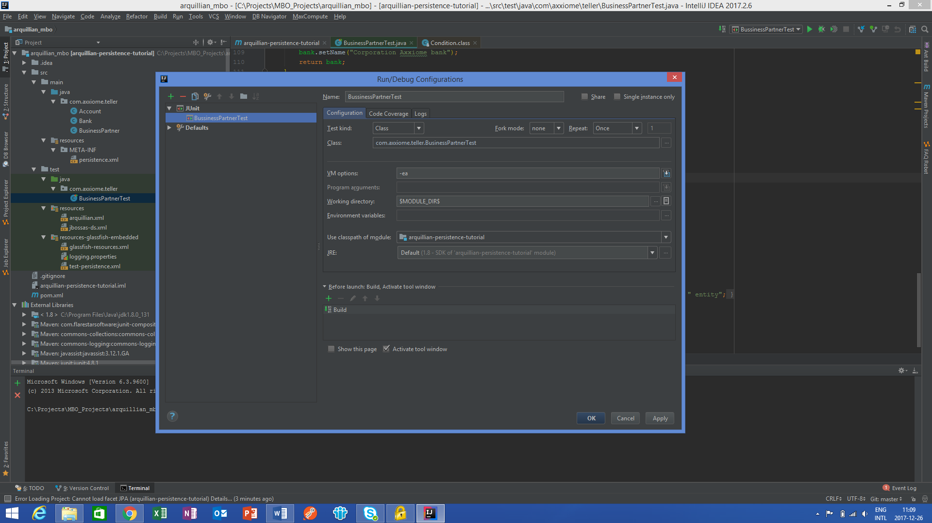

Select test and run
